**1. What are events in Google analytics?**In Google Analytics, **events** are user interactions with content that can be tracked separately from pageviews. These interactions are often specific actions that happen on your website or app, such as clicking a button, watching a video, downloading a file, or completing a form.

Events in Google Analytics are tracked using the **Event Tracking** feature, which allows you to collect and analyze data about actions that don’t necessarily result in a page loading. Each event typically consists of four components:

**Category**: This is the name you assign to the group of events (e.g., "Video," "Download," "Form").

**Action**: This describes the specific action the user took (e.g., "Play," "Download," "Submit").

**Label** (optional): This provides additional information about the event (e.g., the name of the video, the file being downloaded).

**Value** (optional): This is a numeric value that represents the event’s significance (e.g., a price, time spent on a video, or score).  
  
**2. Connect your created website and blog to search console, analytics, and google tag manager and add your faculty as a user with required permission in it.   
  
search console:   
  
https://drive.google.com/file/d/142vJFVtK10nM8zQfn7Q6Mlo5BBNIzIgQ/view?usp=sharing  
  
Report:   
  
https://docs.google.com/spreadsheets/d/1FFII2CKmWNsZwBU7RW-oFt-QMXvLsVtD/edit?usp=sharing&ouid=105593835773971789057&rtpof=true&sd=true**

**Google Analytics:  
  
https://drive.google.com/file/d/1PSvvSLTPxzvF-7ES_juAqqzmeH3U30zz/view?usp=sharing**

**GoogleTag Manager:  
  
https://drive.google.com/file/d/1mXlfv4ENlPgBrmRXuf9i7vvkCDYZrWRG/view?usp=sharing  
  
3. Submit the sitemap and robot.txt file in the search console for your website.**[**https://drive.google.com/file/d/1T6IvD3QvkrTgCTQtpjJB5spyKUZ_BJGL/view?usp=sharing**](https://drive.google.com/file/d/1T6IvD3QvkrTgCTQtpjJB5spyKUZ_BJGL/view?usp=sharing) **4. Submit the user flow and traffic source reports for your website.  
  
  
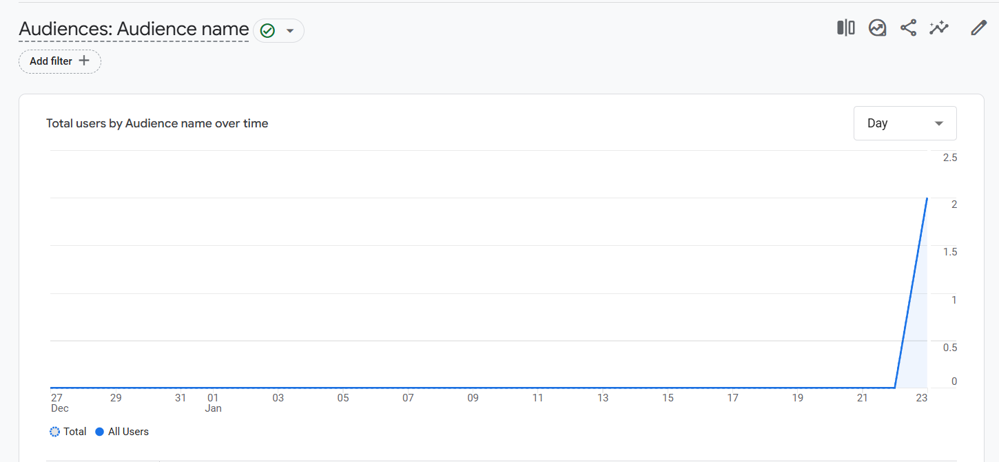**

**5. Connect your blog to Google Analytics and study the different types of traffic on your site**

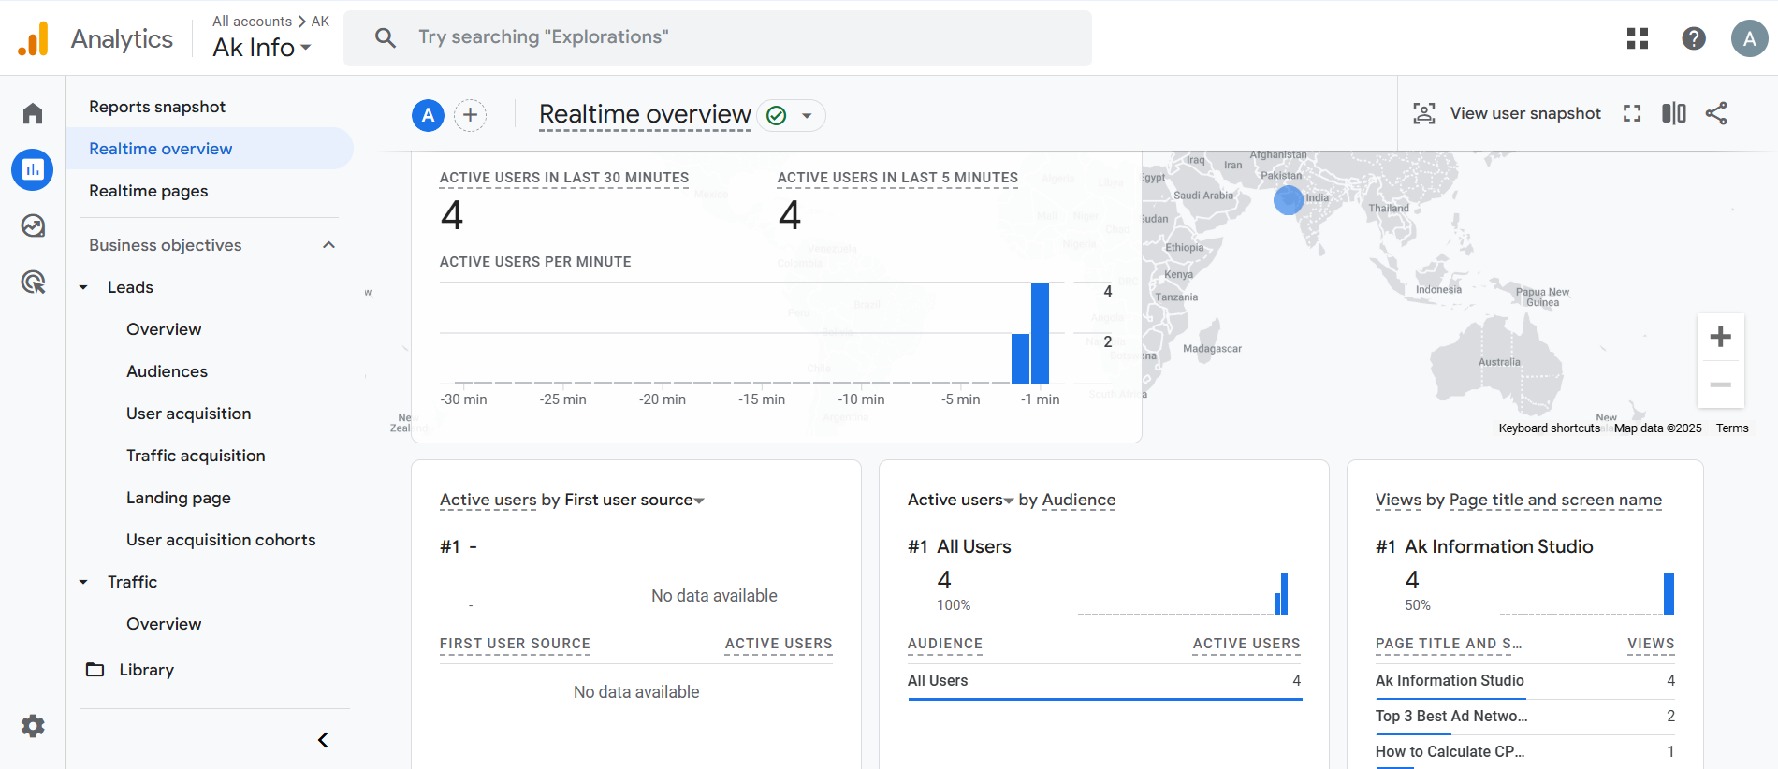

**6. Create a goal for your business and study reports whether it has been completed or not.**

